This project has received funding from the European’s Union Horizon 2020 research innovation programme under Grant Agreement No. 957258
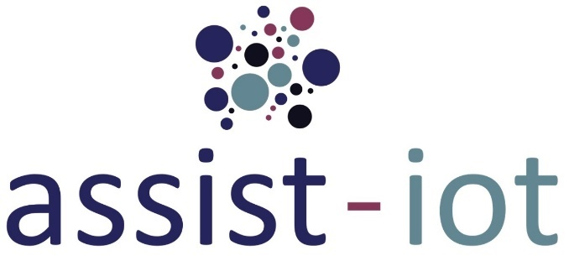

Proposal Template
for
ASSIST-IoT Open Call application

Administrative Information (Registration form)
PART - I | Name of the submitter
 | Email address of submitter
 | Country
 | Organisation
 | Type of organisation
 | PIC of organisation
 | Website of the organisation

PART - II | Title of the project
 | Acronym of the project
 | Pilot which is addressed to
 | Challenge within pilot
 | Abstract (250 chars)
 | Keywords
This page is not considered for the 15-pages limit.
PART - III | Project duration (months)
 | Budget for the project

Idea
[Delete this guidance box in your submitted version]
This section must cover (at least, but not limited to) the following points:
  - Main idea of the project and how it is related with the specific challenge of the selected pilot.
  - Innovation (how the project goes beyond already existing solutions)
  - Technology underlying the project, providing enough block diagrams and illustrative pictures to understand the process and how it will work interacting with ASSIST-IoT.
  - Observable and tangible results (application, GUI, software, hardware, protocol, methodology).
  - Background of the solution (where it comes from, software it builds atop, etc.).
* Here, it is worth mentioning that software development and hardware/firmware integration will need to be compliant with ASSIST-IoT Architectural guidelines (mainly relevant: enablers encapsulation, containerisation/virtualisation and OpenAPI). Please, consult in detail the Appendix B - Technical framework of the Guide for Applicants in the Application Package.
Maximum length of this section: 5 pages.

Relevance to ASSIST-IoT
[Delete this guidance box in your submitted version]
This section must cover (at least, but not limited to) the following points:
- Describe how the idea matches ASSIST-IoT overarching goals (https://assist-iot.eu/objectives/ )
- Describe how the solution will contribute to enhance the scope of the selected pilot? (https://assist-iot.eu/use-cases )
- Describe how it will enhance (and which part of) the architecture of ASSIST-IoT.
Maximum length of this section: 1 page.

Impact and sustainability
[Delete this guidance box in your submitted version]
This section must cover (at least, but not limited to) the following points:
- Which is the expected impact of the solution during ASSIST-IoT project?
- Which are the mid- and long- term indicators that could be monitored to measure the impact of your solution? Attempt to quantify such estimated impact.
- How will you ensure the sustainability of the work beyond the end of the funding? Please indicate any additional sources of funding/support you may need and how you plan to secure it
- Explain every expected publication (scientific paper, congress article, etc.).
- Standardisation and roll-out potential
Maximum length of this section: 2 pages.

Implementation
[Delete this guidance box in your submitted version]
This section must cover (at least, but not limited to) the following points:
- Gantt of the project (Note that the max. duration for OC#1 is 9 months)
- Explanation of the work plan (divided in tasks) as detailed as possible.
- Describe the necessary means to realise the idea (data, equipment, connectivity, access to infrastructure, systems, etc.).
- Milestones (max.4) and deliverables (max. 8 including reports and other – e.g., software).
* Here, it is worth mentioning that deliverables and milestones should be aligned with the planned “payment milestones”, which for the first round of Open Calls are: (a) Intermediate payment (M24- October, 31st 2022) and (b) Final payment (M27 – January, 31st, 2023).
Maximum length of this section: 4 pages.

Team
[Delete this guidance box in your submitted version]
This section must cover (at least, but not limited to) the following points:
- List the relevant members of your team, indicating gender (voluntarily), their relevant skills and experience.
- Indicate the structure of the team and the roles and responsibilities that each member will be taking.
- Experience of the organisation (relevant previous projects, services, contracts, etc.).
Maximum length of this section: 2 pages.

Other relevant aspects
[Delete this guidance box in your submitted version]
This section must cover (at least, but not limited to) the following points:
- Which (if any) data do you intend to gather or produce? How much of this will be openly available?
- Do you rely on personal data? If so, how will you store this data? All pilots will be expected to comply with the General Data Protection Regulation 2016/679 (GDPR).
- Mention any IPR background existing.
Maximum length of this section: 1 page.

 | Estimated eligible costs (per budget category) |  | Financial Support
 | A. Costs (direct and indirect costs) | Total costs | Reimbursement rate % | Maximum Financial  Support ² | Requested financial support
Form of costs ³ | Pre-defined Lump sum
Third Party |  |  | 100

Budget of the project

This page is not considered for the 15-pages limit.

